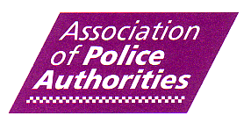

APA Olympics Police Authority Meeting

4th March 2009 2.30pm to 4.30pm
Association of Police Authorities
15 Greycoat Place, London SW1P 1BN

AGENDA

1) Introductions/ Apologies (Chair- Simon Duckworth- APA Board Member & Chair of City of London Corporation)

2) Governance and the Olympic Safety & Security Strategy (Home Office/ OSCT Representatives)

3) Concept of Operations and 5 Core Delivery Work Streams (Home Office/ OSCT Representatives)

4) Discussion, Future Police Authority Engagement and Next Steps (Chair/ All)

